Write a program to find a numerology destiny number of a given name:

Numerology numbers are a sum value of the name numbers. Sum the numerology number from the given number alphabet chart.

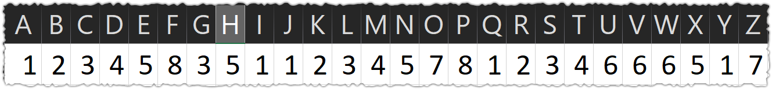

Example:

Name: Ajithkumar



Compound Name Number: 27

Destiny Number: 2 + 7 = 9

// constant cannot be reassigned

const PI = 3.14159265;

PI = 3.14;

PI = PI + 10;

console.log(PI);